Virtual
Coxswain

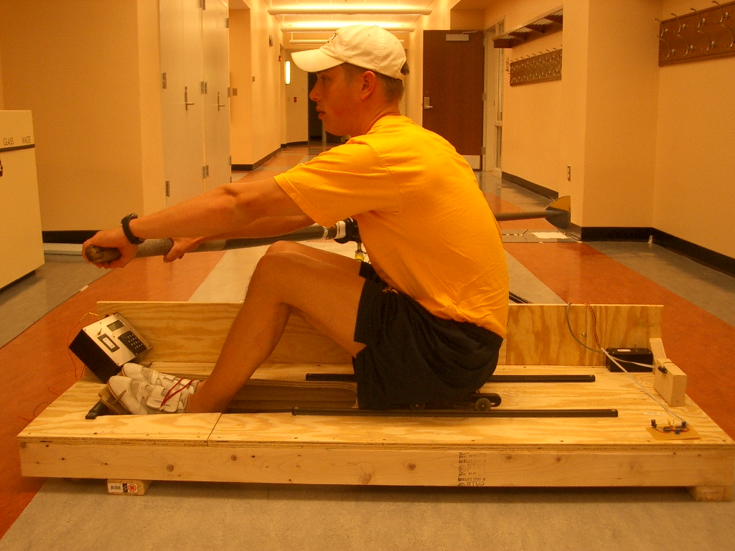

MIDN 1/C Nick Rygiel Advisors: ES402
MIDN 1/C Jeff Morrison Capt. Noble Final Design Paper
MIDN 1/C Paul Marcy Prof. Watkins 29APR04

